Trapezoidal Wedge

Definition
# Source: AI Source: Provided by: [Data Path: Persons Table -> ID Column: 1, Name_En Column: Motasem Essam] -> From: [ChatGPT] on [7/25/2026]
A Trapezoidal Wedge is a three-dimensional geometric solid bounded by two triangular faces and three trapezoidal faces.
It is a type of wedge whose exterior surface consists of five polygonal faces. Its shape is formed by connecting the sides of two triangular faces with three trapezoidal surfaces.
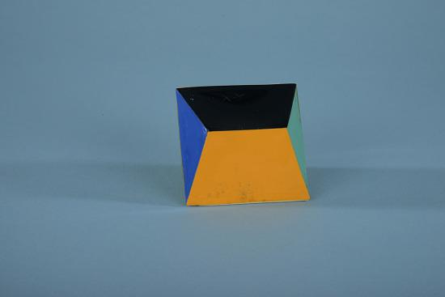
<caption>Trapezoidal wedge – geometric model. The Smithsonian describes this solid as having two triangular faces and three trapezoidal faces. </caption>

Simple Definition
# Source: AI Source: Provided by: [Data Path: Persons Table -> ID Column: 1, Name_En Column: Motasem Essam] -> From: [ChatGPT] on [7/25/2026]
A trapezoidal wedge is a five-faced polyhedron consisting of two triangular faces connected by three trapezoidal faces.
Unlike an ordinary triangular prism, its lateral faces are trapezoids rather than necessarily rectangles or parallelograms.
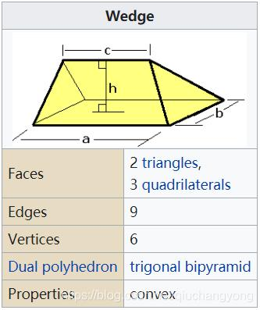

Geometric Structure
# Source: AI Source: Provided by: [Data Path: Persons Table -> ID Column: 1, Name_En Column: Motasem Essam] -> From: [ChatGPT] on [7/25/2026]
The trapezoidal wedge consists of three main structural components:
- First triangular face: One triangular end of the solid.
- Second triangular face: The other triangular end.
- Three trapezoidal lateral faces: Connect the corresponding sides of the two triangular faces.
Its structure produces six vertices and nine edges.

Face Structure
# Source: AI Source: Provided by: [Data Path: Persons Table -> ID Column: 1, Name_En Column: Motasem Essam] -> From: [ChatGPT] on [7/25/2026]
A trapezoidal wedge has 5 faces.
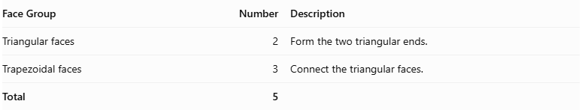
Face Group | Number | Description
Triangular faces | 2 | Form the two triangular ends.
Trapezoidal faces | 3 | Connect the triangular faces.
Total | 5
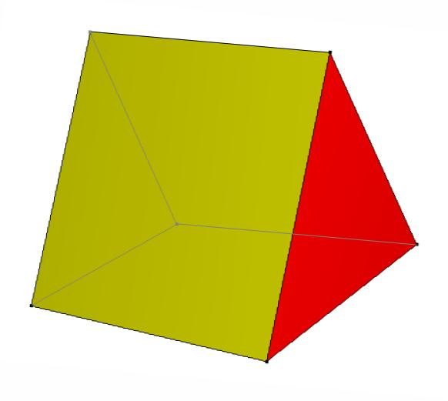

Edge Structure
# Source: AI Source: Provided by: [Data Path: Persons Table -> ID Column: 1, Name_En Column: Motasem Essam] -> From: [ChatGPT] on [7/25/2026]
A trapezoidal wedge has 9 edges.
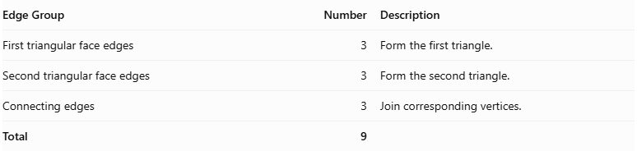
Edge Group | Number | Description
First triangular face edges | 3 | Form the first triangle.
Second triangular face edges | 3 | Form the second triangle.
Connecting edges | 3 | Join corresponding vertices.
Total | 9

Vertex Structure
# Source: AI Source: Provided by: [Data Path: Persons Table -> ID Column: 1, Name_En Column: Motasem Essam] -> From: [ChatGPT] on [7/25/2026]
A trapezoidal wedge has 6 vertices.
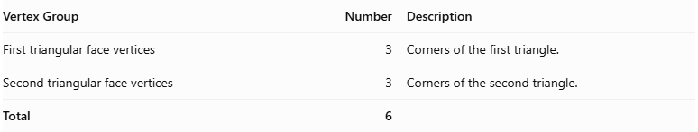
Vertex Group | Number | Description
First triangular face vertices | 3 | Corners of the first triangle.
Second triangular face vertices | 3 | Corners of the second triangle.
Total | 6

Mathematical Properties
# Source: AI Source: Provided by: [Data Path: Persons Table -> ID Column: 1, Name_En Column: Motasem Essam] -> From: [ChatGPT] on [7/25/2026]
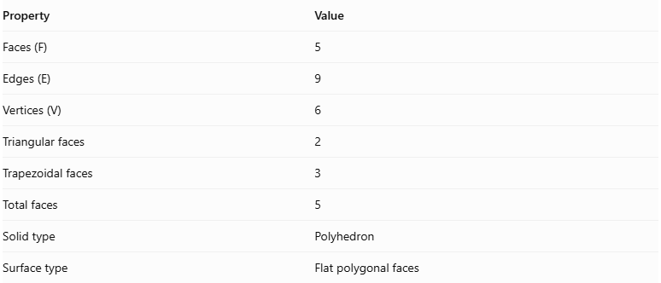
Property | Value
Faces (F) | 5
Edges (E) | 9
Vertices (V) | 6
Triangular faces | 2
Trapezoidal faces | 3
Total faces | 5
Solid type | Polyhedron
Surface type | Flat polygonal faces
It satisfies Euler's polyhedron formula:
$$V-E+F=2$$
Substituting:
$$6-9+5=2$$
Therefore, the trapezoidal wedge satisfies Euler's formula.

Surface Area
# Source: AI Source: Provided by: [Data Path: Persons Table -> ID Column: 1, Name_En Column: Motasem Essam] -> From: [ChatGPT] on [7/25/2026]
The total surface area is the sum of the areas of its two triangular faces and three trapezoidal faces.
$$\boxed{S=A_{1}+A_{2}+A_{3}+A_{4}+A_{5}}$$
Where:
- $A_{1},A_{2}$ are the areas of the two triangular faces.
- $A_{3},A_{4},A_{5}$ are the areas of the three trapezoidal faces.
The area of a triangle is:
$$A_{t}=\frac{1}{2}bh$$
The area of a trapezoid is:
$$A_{\text{trap}}=\frac{1}{2}(a+b)h$$
Where $a$ and $b$ are the parallel sides and $h$ is the perpendicular distance between them.

Volume
# Source: AI Source: Provided by: [Data Path: Persons Table -> ID Column: 1, Name_En Column: Motasem Essam] -> From: [ChatGPT] on [7/25/2026]
The volume of a trapezoidal wedge depends on the dimensions and spatial arrangement of its faces.
For a wedge with two parallel triangular end faces, the prismoidal formula can be used:
$$\boxed{V=\frac{h}{6}(A_{1}+4A_{m}+A_{2})}$$
Where:
- $A_{1}$ = area of the first triangular face.
- $A_{2}$ = area of the second triangular face.
- $A_{m}$ = area of the cross-section halfway between the triangular faces.
- $h$ = perpendicular distance between the two triangular faces.
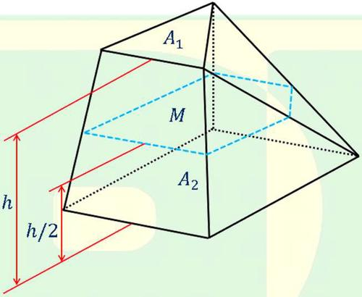
Note: This volume formula applies to the parallel-end prismoid configuration, not automatically to every possible wedge.

Symmetry
# Source: AI Source: Provided by: [Data Path: Persons Table -> ID Column: 1, Name_En Column: Motasem Essam] -> From: [ChatGPT] on [7/25/2026]
The symmetry of a trapezoidal wedge depends on its geometric dimensions and arrangement.
- A symmetrical trapezoidal wedge may have a plane of reflection symmetry.
- An irregular trapezoidal wedge may have no reflection symmetry.
- Its symmetry depends on the shapes and relative positions of its triangular and trapezoidal faces.
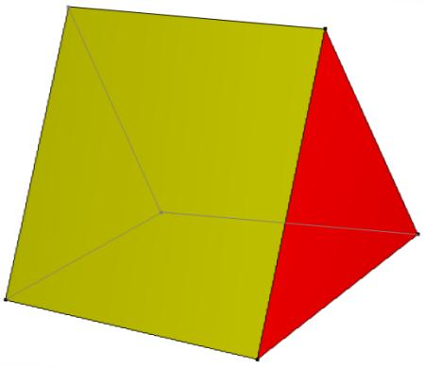

Relationship to Other Solids
# Source: AI Source: Provided by: [Data Path: Persons Table -> ID Column: 1, Name_En Column: Motasem Essam] -> From: [ChatGPT] on [7/25/2026]
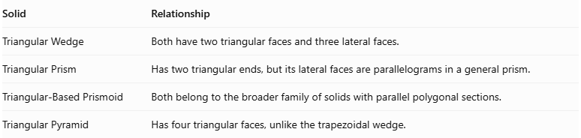
Solid | Relationship
Triangular Wedge | Both have two triangular faces and three lateral faces.
Triangular Prism | Has two triangular ends, but its lateral faces are parallelograms in a general prism.
Triangular-Based Prismoid | Both belong to the broader family of solids with parallel polygonal sections.
Triangular Pyramid | Has four triangular faces, unlike the trapezoidal wedge.
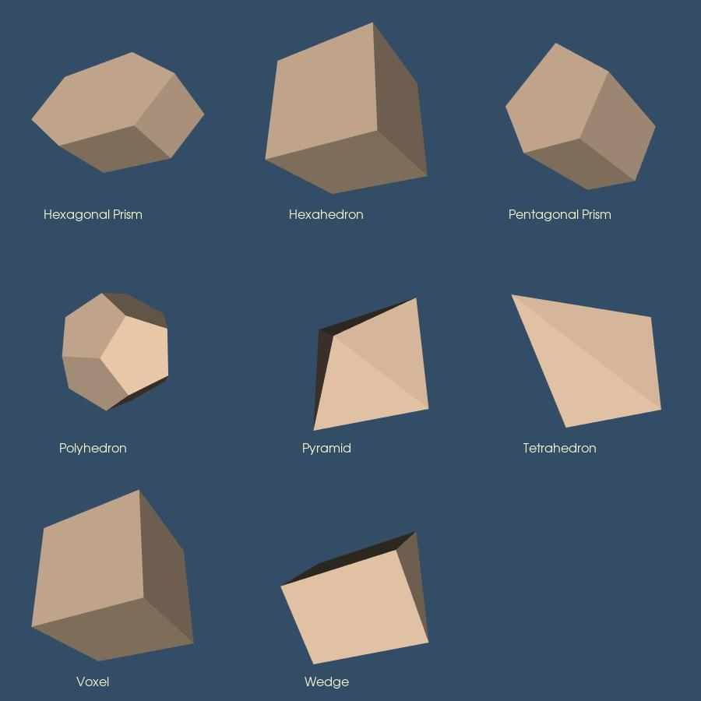

Worked Examples

Example 1: Calculate Faces, Edges, and Vertices
# Source: AI Source: Provided by: [Data Path: Persons Table -> ID Column: 1, Name_En Column: Motasem Essam] -> From: [ChatGPT] on [7/25/2026]
For a trapezoidal wedge:
- Triangular faces = 2
- Trapezoidal faces = 3
- Edges = 9
- Vertices = 6
Therefore:
$$F=2+3=5$$
$$E=9$$
$$V=6$$

Example 2: Calculate Surface Area
# Source: AI Source: Provided by: [Data Path: Persons Table -> ID Column: 1, Name_En Column: Motasem Essam] -> From: [ChatGPT] on [7/25/2026]
Suppose a trapezoidal wedge has the following face areas:
- First triangular face = $12{\text{ cm}}^{2}$
- Second triangular face = $15{\text{ cm}}^{2}$
- First trapezoidal face = $20{\text{ cm}}^{2}$
- Second trapezoidal face = $18{\text{ cm}}^{2}$
- Third trapezoidal face = $22{\text{ cm}}^{2}$
Using:
$$S=A_{1}+A_{2}+A_{3}+A_{4}+A_{5}$$
$$S=12+15+20+18+22$$
$$\boxed{S=87{\text{ cm}}^{2}}$$

Constructing Trapezoidal Wedge in Solid Geometry

Geometric Instruments Used
# Source: AI Source: Provided by: [Data Path: Persons Table -> ID Column: 1, Name_En Column: Motasem Essam] -> From: [ChatGPT] on [7/25/2026]

- Ruler: Drawing straight edges.
- Compass: Drawing arcs and transferring distances.
- Protractor: Measuring angles.
- Set square: Drawing perpendicular and parallel lines.
- Pencil: Drawing construction lines.
- Eraser: Removing unnecessary construction marks.

Instrument-Based Construction Procedures

A. Constructing the First Triangular Face
# Source: AI Source: Provided by: [Data Path: Persons Table -> ID Column: 1, Name_En Column: Motasem Essam] -> From: [ChatGPT] on [7/25/2026]
- Draw a triangle using a ruler.
- Mark its vertices as A, B, and C.
- Complete the triangular outline.

B. Constructing the Second Triangular Face
# Source: AI Source: Provided by: [Data Path: Persons Table -> ID Column: 1, Name_En Column: Motasem Essam] -> From: [ChatGPT] on [7/25/2026]
- Draw the second triangular face in a different position.
- Mark its vertices as A′, B′, and C′.
- Arrange the two triangles according to the required wedge dimensions.

C. Constructing the Trapezoidal Faces
# Source: AI Source: Provided by: [Data Path: Persons Table -> ID Column: 1, Name_En Column: Motasem Essam] -> From: [ChatGPT] on [7/25/2026]
- Connect vertex A to A′.
- Connect vertex B to B′.
- Connect vertex C to C′.
- Construct the three lateral quadrilateral faces.
- Adjust their outlines to form trapezoidal faces.

D. Completing the Trapezoidal Wedge
# Source: AI Source: Provided by: [Data Path: Persons Table -> ID Column: 1, Name_En Column: Motasem Essam] -> From: [ChatGPT] on [7/25/2026]
- Check that the solid has two triangular faces.
- Check that it has three trapezoidal lateral faces.
- Darken the visible edges.
- Draw hidden edges using dashed lines when necessary.
- Remove unnecessary construction marks.
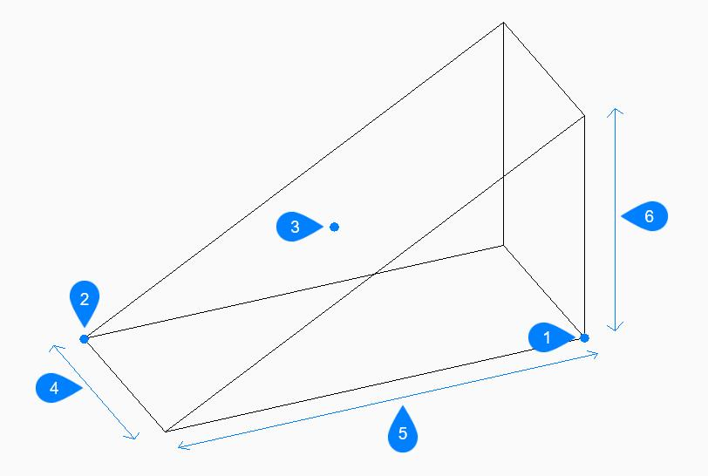

Key Points
# Source: AI Source: Provided by: [Data Path: Persons Table -> ID Column: 1, Name_En Column: Motasem Essam] -> From: [ChatGPT] on [7/25/2026]
- A trapezoidal wedge is a three-dimensional polyhedron.
- It has two triangular faces.
- It has three trapezoidal faces.
- It has 5 faces in total.
- It has 9 edges.
- It has 6 vertices.
- Its total surface area is the sum of the areas of all five faces.
- Its volume depends on its dimensions and geometric arrangement.

Conclusion
# Source: AI Source: Provided by: [Data Path: Persons Table -> ID Column: 1, Name_En Column: Motasem Essam] -> From: [ChatGPT] on [7/25/2026]
A Trapezoidal Wedge is a polyhedron consisting of two triangular faces connected by three trapezoidal faces. It has 5 faces, 9 edges, and 6 vertices.
Its defining characteristic is its combination of triangular end faces and trapezoidal lateral faces, distinguishing it from an ordinary triangular prism.

